**Activity 1.**

1. Examine the various theories of leadership and their definitions, explain.

1. **Great Man Theory**:
   * **Definition**: The Great Man Theory posits that leaders are born, not made. It suggests that leaders possess inherent qualities, such as charisma, intelligence, and courage, that make them effective leaders.
   * **Application in the Workplace**: This theory implies that leadership is innate and not something that can be developed through training or experience. Therefore, in the workplace, it may lead to a belief that leaders cannot be created, only identified. It can limit opportunities for leadership development.
   * **Advantages**: It emphasizes the importance of exceptional leadership qualities, which can be inspiring and motivate individuals to aspire to be better leaders.
   * **Disadvantages**: It is overly simplistic and does not consider the impact of situational factors or the development of leadership skills over time.
2. **Trait Theory**:
   * **Definition**: Trait theory, like the Great Man Theory, suggests that certain personality traits and characteristics, like intelligence, confidence, and integrity, are inherent to effective leaders.
   * **Application in the Workplace**: In the workplace, trait theory can guide selection and promotion decisions by focusing on identifying individuals with the desired leadership traits. It can also be used for leadership development programs, targeting the enhancement of specific traits.
   * **Advantages**: It provides a framework for assessing potential leaders and tailoring leadership development programs. It can be helpful in identifying candidates for leadership roles.
   * **Disadvantages**: It oversimplifies leadership by suggesting that leadership effectiveness depends solely on specific traits. It doesn't consider situational or contextual factors that can influence leadership success.
3. **Contingency Theory**:
   * **Definition**: Contingency theory suggests that the effectiveness of leadership is contingent upon the situation or context. Different situations require different leadership styles.
   * **Application in the Workplace**: In the workplace, leaders using contingency theory may adapt their leadership styles to fit the specific needs of a situation. For example, a crisis may require a different leadership approach than a routine day-to-day operation.
   * **Advantages**: It recognizes the importance of adapting leadership to the unique demands of different situations. It allows for flexibility and responsiveness.
   * **Disadvantages**: It can be complex and challenging to implement as it requires leaders to have a deep understanding of various situations and the ability to adjust their leadership style accordingly.
4. **Participative Leadership**:
   * **Definition**: Participative leadership, also known as democratic leadership, involves leaders collaborating with their team members, seeking their input, and making decisions collectively.
   * **Application in the Workplace**: In the workplace, participative leadership can lead to increased employee engagement, empowerment, and better decision-making through the inclusion of diverse perspectives. It is especially effective in knowledge-based industries.
   * **Advantages**: It fosters a sense of ownership and commitment among team members, which can improve motivation and productivity. It leverages the collective wisdom of the group.
   * **Disadvantages**: It may not be suitable for all situations, as it can be time-consuming and less effective in urgent or crisis situations. It also requires leaders to be skilled facilitators.

2. Explain the following roles of a leader, by describing how you would show the following roles as a leader.

a. **Motivating Self and Others**:

* **Setting a Positive Example**: As a leader, you can motivate yourself and others by setting a positive example. Display a strong work ethic, enthusiasm, and a can-do attitude. Your actions and attitude will inspire your team.
* **Recognizing and Rewarding Achievements**: Acknowledge and reward the achievements of your team members. This can be done through verbal praise, promotions, or even small tokens of appreciation. Recognizing their efforts boosts morale and motivation.

b. **Facilitating a Developmental Environment**:

* **Identify Individual Needs**: Recognize the unique strengths and weaknesses of each team member. Tailor your approach to their specific developmental needs. Offer resources or training where necessary.
* **Encourage Continuous Learning**: Promote a culture of continuous learning and improvement. Encourage your team to seek out new knowledge and skills, and provide resources or time for them to do so.
* **Mentoring and Coaching**: Offer guidance and mentorship to team members. Provide coaching and regular feedback to help them develop professionally. Support their career goals and aspirations.

c. **Being an Innovator**:

* **Encourage Creative Thinking**: Foster a culture of innovation by encouraging your team to think creatively and brainstorm ideas. Create a safe space for sharing new concepts and suggestions.
* **Lead by Example**: Demonstrate your own innovative thinking and risk-taking. Be open to new ideas and be willing to experiment. Your willingness to innovate sets the tone for your team.
* **Provide Resources and Support**: Ensure that your team has access to the necessary resources, such as time, technology, or training, to support their innovative endeavours.
* **Risk Management**: While promoting innovation, also emphasize responsible risk-taking. Ensure that your team understands the potential risks and consequences of their innovative projects and has a plan to mitigate them.
* **Celebrate Innovation**: Recognize and celebrate innovative achievements within your team. Publicly acknowledge and reward creative problem-solving and successful innovations.

3. What are the roles and qualities of a leader? Give a comprehensive explanation with at least 5 example qualities and how they relate to those of a Manager in the workplace.

|  |  |  |
| --- | --- | --- |
| **Aspect** | **Leader** | **Manager** |
| **Roles** | **Setting a vision and direction:** A leader articulates a compelling vision for the future, outlining the path for the organization or team to follow.  **Inspiring and motivating:** They inspire and motivate others through their passion and vision, encouraging commitment and dedication.  **Building and nurturing relationships:** A leader fosters trust and collaboration among team members, creating a positive and inclusive environment.  **Adaptability and innovation:** They encourage innovation and adaptability, being open to new ideas and changes to drive progress. | **Planning and organizing:** Managers are responsible for planning the steps required to achieve the goals set by the leader.  **Implementing and** **controlling:** They oversee the execution of plans and control the processes to ensure they align with the organization's objectives.  **Problem-solving:** Managers are often involved in troubleshooting and resolving day-to-day issues that arise in the workplace.  **Resource allocation:** They allocate resources efficiently, managing budgets, personnel, and other resources effectively.  **Performance evaluation:** Managers assess the performance of their team members, providing feedback and facilitating growth. |
| **Qualities** | **Vision**: A leader possesses a clear and inspiring vision for the future, guiding the team toward a common goal.  **Empathy**: They understand and connect with their team members, showing empathy and supporting their needs.  **Integrity:** Leaders demonstrate honesty, transparency, and ethical behaviour, earning the trust of their team.  **Adaptability**: They embrace change and encourage a culture of adaptability and learning within the team.  **Influence:** A leader's influence extends beyond authority; they inspire and persuade others to achieve shared objectives. | **Organizational skills:** Managers excel in organizing resources, time, and efforts efficiently to meet objectives.  **Detail-oriented:** They pay attention to details, ensuring tasks are executed accurately and according to plan.  **Problem-solving:** Managers are adept at addressing challenges and finding solutions promptly.  **Technical competence:** They possess the technical skills required for the tasks at hand and guide team members as needed.  **Decision-making:** Managers make informed decisions, weighing risks and benefits to achieve desired outcomes. |

4. Compare the role of a leader and a manager in terms of their complementary roles, use the table below as an example to answer the question.

|  |  |  |
| --- | --- | --- |
| **Activity** | **Management** | **Leadership** |
| **Executing Plans** | Managers focus on the implementation of plans and ensuring that tasks are completed according to the established procedures and timelines.  They prioritize efficiency, resource allocation, and quality control. - Managers typically monitor and control day-to-day operations, making sure that everything runs smoothly. | Leaders inspire and motivate their teams to execute plans with enthusiasm and dedication. They emphasize the "why" behind the plan, connecting it to the organization's vision and goals, which can boost morale and commitment.  Leaders often encourage creativity and innovation within the plan execution process, seeking new, more effective ways of achieving objectives. |

**Activity 2.**

1. Types of Teams:

**a. Cross-Functional Teams:**

* **Unique Role:** Cross-functional teams consist of members from various functional areas, bringing diverse expertise to solve specific issues or projects.
* **Importance:** Critical for innovation, problem-solving, and improving coordination across departments.
* **Difference from Groups:** Teams have a shared purpose, interdependence, and specific roles, while groups may lack a common goal and exhibit less interaction.
* **Achieving Team Dynamics:** Achieved by creating a shared understanding of goals, fostering open communication, and leveraging diverse skills. For example, a cross-functional team of engineers, marketers, and finance professionals works together to develop a new product.

**b. Virtual Teams:**

* **Unique Role:** Virtual teams collaborate online, often across geographic locations, using technology as their primary means of communication.
* **Importance:** Facilitate global collaboration, reduce costs, and harness specialized skills.
* **Difference from Groups:** Virtual teams require effective online communication and coordination, unlike groups that often meet face-to-face.
* **Achieving Team Dynamics:** Team dynamics in virtual teams are achieved through strong online leadership, clear communication channels, and trust-building. For example, a virtual marketing team from different time zones uses video conferencing and project management tools to collaborate effectively.

**c. Project Teams:**

* **Unique Role:** Project teams are formed for a specific task or project, and their existence is temporary.
* **Importance:** Essential for completing projects efficiently, meeting deadlines, and achieving project objectives.
* **Difference from Groups:** Project teams have a specific project focus, clear deliverables, and defined timelines, while groups often have ongoing, less structured purposes.
* **Achieving Team Dynamics:** Project team dynamics are formed by setting clear project goals, defining roles, and maintaining effective communication. For example, a project team in a software development company works on launching a new software application.

2. Process of Building a Team:

1. **Establish Clear, Achievable Goals:** Setting clear and achievable goals is paramount, as it provides the team with a common purpose and direction. Without well-defined objectives, a team may lack focus and motivation.
2. **Set a Clear Plan:** A detailed plan outlines the roadmap for achieving the established goals. It helps the team understand the steps needed to succeed and minimizes confusion or ambiguity.
3. **Define Roles Clearly:** Clear role definition ensures that every team member understands their responsibilities, which promotes accountability and effective collaboration.
4. **Insist on Clear Communication:** Effective communication is the foundation of successful teamwork. Encouraging open and transparent communication helps prevent misunderstandings and conflicts.
5. **Feedback and Recognition:** Providing constructive feedback and recognizing team members' contributions fosters a positive team environment. It boosts morale, motivation, and a sense of accomplishment.

3. Role of the Team Leader in Improving Team Effectiveness:

* A team leader is responsible for setting clear goals, providing guidance, promoting open communication, offering support, and resolving conflicts. They create a positive team culture and foster motivation, trust, and collaboration among team members.

4. Impact of Different Leadership Styles on Team Effectiveness:

* Transformational Leadership can inspire and motivate team members, leading to higher motivation and innovation.
* Transactional Leadership can be effective with self-motivated team members and for short-term task-focused objectives.
* Situational Leadership adapts leadership styles based on the team's readiness and the situation, achieving the best results for each scenario.

5. Constructive Management Techniques for Team Dynamics:

1. **Clear Communication:** Effective communication is at the core of successful team dynamics. It involves sharing information, updates, and expectations transparently, which minimizes misunderstandings and conflicts.
2. **Active Listening:** Actively listening to team members' ideas, concerns, and feedback fosters a sense of inclusion and respect. It encourages open dialogue and promotes trust within the team.
3. **Conflict Resolution:** The ability to address conflicts and disputes constructively is vital for maintaining a harmonious team environment. Conflict resolution techniques help prevent issues from escalating and enable the team to work through differences.
4. **Feedback and Recognition:** Providing regular feedback and recognizing team members' contributions and achievements boosts morale, motivation, and a sense of belonging. Positive reinforcement encourages continued effort and commitment.
5. **Setting Clear Expectations:** Clearly defining roles, responsibilities, and performance expectations within the team is crucial. When team members know what is expected of them, it leads to more efficient and productive collaboration.

**Activity 3.**

**Question 1: Analysing Leadership Styles**

1. **Transformational Leadership (Leader A):** This style focuses on inspiration and motivation. Nelson Mandela, the former President of South Africa, exemplified transformational leadership. His vision for a racially unified nation and his ability to inspire hope and change among the people demonstrated this leadership style.
2. **Democratic Leadership (Leader B):** Barack Obama, the 44th President of the United States, embraced a democratic leadership style. He involved diverse perspectives, encouraged participation, and valued consensus-building in decision-making processes during his presidency.
3. **Autocratic and Transactional Leadership Blend (Leader C):** Robert Mugabe, the late former President of Zimbabwe, exhibited a blend of autocratic and transactional styles. Mugabe was known for his strong, rule-based approach to governance, often emphasizing outcomes and rules to maintain control.

**Effect on Followers:**

1. **Transformational Leadership (Leader A - Mandela):** Mandela's transformational style inspired immense motivation and innovation among his followers. His leadership during South Africa's transition from apartheid to democracy brought about positive change and heightened morale among the populace.
2. **Democratic Leadership (Leader B - Obama):** Obama's democratic style likely increased job satisfaction among citizens by involving them in decision-making processes. However, this participatory approach might have caused delays in decision-making, a trade-off for inclusivity.
3. **Autocratic and Transactional Leadership Blend (Leader C - Mugabe):** Mugabe's leadership style possibly led to higher productivity due to clear expectations and stringent enforcement. However, his rule was controversial and might have decreased overall job satisfaction among Zimbabweans due to political oppression and economic difficulties.

**Role Models:**

1. **Transformational Leadership (Leader A - Mandela):** Mandela served as an exceptional role model, exhibiting ethical behaviour, resilience, and commitment to a mission of equality and reconciliation. His personal sacrifices and moral integrity positively influenced his followers.
2. **Democratic Leadership (Leader B - Obama):** Obama served as a role model by fostering open communication, teamwork, and inclusivity, which positively impacted followers and citizens.
3. **Autocratic and Transactional Leadership Blend (Leader C - Mugabe):** Mugabe's leadership might not have been seen as a positive role model due to his strict adherence to rules, political repression, and economic challenges faced during his tenure.

**Trends in Leadership Theories:**

Leadership theories have evolved from focusing solely on traits and behaviours to emphasizing transformational, servant, authentic, and adaptive leadership. Leaders like Mandela and Obama embody aspects of these newer theories by inspiring change, fostering inclusivity, and displaying empathy towards their followers' needs. Mugabe's leadership style, while effective in some respects, did not align as well with these modern theories due to its more authoritarian nature.

**Question 2: Personal Profile**

**2.1**

**Philasande Bhani** *Software Developer | Intermediate Developer*

**Leadership Style:** Transformational Leader

* Inspires and motivates teams toward their full potential
* Fosters innovation, creativity, and growth among team members
* Encourages a shared vision and values within the workplace

**Roles, Qualities, and Abilities:**

* **Visionary:** Envisions the future of projects and team growth
* **Motivator:** Inspires and drives team members toward common goals
* **Mentor:** Guides and supports team members in skill development
* **Qualities:** Effective communicator, empathetic, adaptable, provides constructive feedback

**Accountability and Compliance:**

* Takes responsibility for adhering to organizational policies
* Regularly reviews and updates policies, educates the team on compliance
* Stays informed about relevant legislation and seeks legal counsel when necessary

**Organizational Structure:**

* Represents the Developer role within the Software Developer team
* Position: Intermediate Developer
* Reports to: Jamie Cotter

**Comparison to Managerial Styles:**

* Focuses on inspiring and motivating teams rather than solely task-oriented management
* Encourages team members to achieve beyond minimum requirements

**Unique Challenges:**

* Challenges in cross-functional collaboration due to differing objectives and priorities within the team
* Potential communication and accountability issues in virtual teams due to geographical separation

**Approach to Challenges:**

* Facilitates alignment of objectives and priorities among cross-functional teams
* Utilizes various communication tools and fosters a culture of accountability in virtual teams

**Professional Goals:**

* Continual growth in leadership skills and team management
* Contributing to innovative software development projects
* Cultivating a collaborative and empowering work environment

**Question 3: Evaluating and Improving Team Effectiveness**

**(A).**

**Team Members:**

Philasande Bhani - Software Developer

Lufuno Mulaudzi - Software Developer

Phumeza Makhiqi - Senior Developer

Nelisiwe Zondi - Intermediate Software Developer

Zanele Queen Mooler - Junior Developer

Katlego - Project Manager

**Performance Matrix:**

KPIs encompass lines of code developed, project completion timelines, bug resolution rates, client satisfaction ratings, team collaboration metrics, and project management efficiency.

|  |  |  |  |  |  |  |
| --- | --- | --- | --- | --- | --- | --- |
| **Team Members** | **Lines of Code Developed** | **Project Completion Timelines** | **Bug Resolution Rates** | **Client Satisfaction Ratings** | **Team Collaboration Metrics** | **Project Management Efficiency** |
| Philasande Bhani | 86% | 92% | 85% | 88% | 89% | 96% |
| Lufuno Mulaudzi | 93% | 91% | 95% | 90% | 98% | 80% |
| Nalisiwe Zondi | 95% | 89% | 93% | 90% | 80% | 86% |
| Zanele Queen Muller | 88% | 96% | 86% | 83% | 86% | 90% |
| Phumeza Makhiqi | 89% | 90% | 81% | 93% | 89% | 90% |
| Katlego Mnkuna | 97% | 98% | 97% | 98% | 92% | 91% |

**(b).**

**Meeting Minutes:**

Detailed minutes outline the expectations, KPIs, and individual responsibilities within the team meeting, ensuring everyone is aware of their roles.

**(C). Project Performance Evaluation Report**

|  |  |  |  |  |
| --- | --- | --- | --- | --- |
| **Performance Metrics** | **Planned (%)** | **Actual (%)** | **Variance** | **Explanation** |
| **Lines of Code Developed** | 90 | 85 | -5 | Unforeseen complexities in coding tasks led to a slight delay in achieving the planned code output. |
| **Project Completion Timelines** | 95 | 90 | -5 | Integration challenges prolonged the project completion timeline. |
| **Bug Resolution Rates** | 98 | 96 | -2 | Increased complexities in debugging affected resolution rates slightly. |
| **Client Satisfaction Ratings** | 92 | 90 | -2 | Minor user interface issues affected overall client satisfaction marginally. |
| **Team Collaboration Metrics** | 88 | 85 | -3 | Communication barriers impacted collaboration efficiency. |
| **Project Management Efficiency** | 94 | 92 | -2 | Tightened schedules affected the project management process slightly. |

**(D). Minutes of Performance Meeting**

**Minutes of Performance Meeting**

**Date: 15 November 2023**

**Attendees:**

Lufuno Mulaudzi

Phumeza Makhiqi

Nelisiwe Zondi

Zanele Queen Muller

Katlego Mnkuna

**Agenda:**

1. Review of Planned vs. Actual Performance
2. Identification of Variances
3. Discussion on Solutions
4. Action Plan Development

**Meeting Minutes:**

* The team reviewed planned versus actual performance for various project metrics, including lines of code developed, project completion timelines, bug resolution rates, client satisfaction ratings, team collaboration metrics, and project management efficiency.
* Variances between expected and actual performance were discussed, highlighting areas that needed improvement.
* Each team member contributed valuable insights and suggestions on how to rectify the identified variances.
* Proposed solutions were evaluated through an open discussion, considering feasibility and potential impact on project outcomes.
* A consensus was reached on the action plan to address non-complying areas, detailing specific tasks, responsible team members, and deadlines.

**(E). Action Plan to Address Non-Complying Areas**

**Objective:**

Enhance project efficiency and performance in key metrics to align with predetermined targets.

**Action Items:**

1. **Weekly Code Review Sessions:**
   * Conduct weekly code review sessions every Friday (November 17, 2023) to identify and rectify coding inefficiencies.
   * Assigned to: Philasande Bhani, Lufuno Mulaudzi, and Nelisiwe Zondi
   * Expected Outcome: Improve lines of code developed and bug resolution rates.
2. **Enhanced Testing Protocols:**
   * Implement additional testing stages every sprint starting on Wednesday (November 15, 2023) to improve bug resolution rates and product quality.
   * Assigned to: Zanele Queen Mooler and Nalisiwe Zondi
   * Expected Outcome: Enhance bug resolution rates and project completion timelines.
3. **Team Collaboration Workshops:**
   * Organize collaborative workshops bi-weekly starting on Thursday (November 16, 2023) to foster better team communication and collaboration.
   * Assigned to: Phumeza Makhiqi and Zanele Queen Mooler
   * Expected Outcome: Improve team collaboration metrics and project management efficiency.
4. **Client Satisfaction Surveys:**
   * Initiate client satisfaction surveys monthly starting on Tuesday (November 14, 2023) to gather feedback and enhance client satisfaction ratings.
   * Assigned to: Katlego Mnkuna and Philasande Bhani
   * Expected Outcome: Boost client satisfaction ratings and project alignment with client expectations.
5. **Project Timeline Reviews:**
   * Schedule bi-weekly project timeline reviews starting on Wednesday (November 15, 2023) to ensure adherence to project completion timelines.
   * Assigned to: Katlego Mnkuna and Phumeza Makhiqi
   * Expected Outcome: Improve project completion timelines.

**Review:**

* Regular progress reviews and updates on action items will be conducted every week starting November 17, 2023.
* Adjustments to the action plan will be made based on ongoing performance evaluations.

**(F). Emails Confirming received action plan**

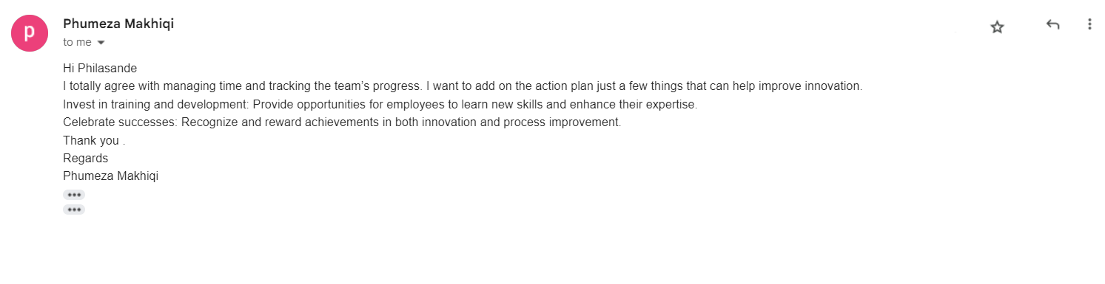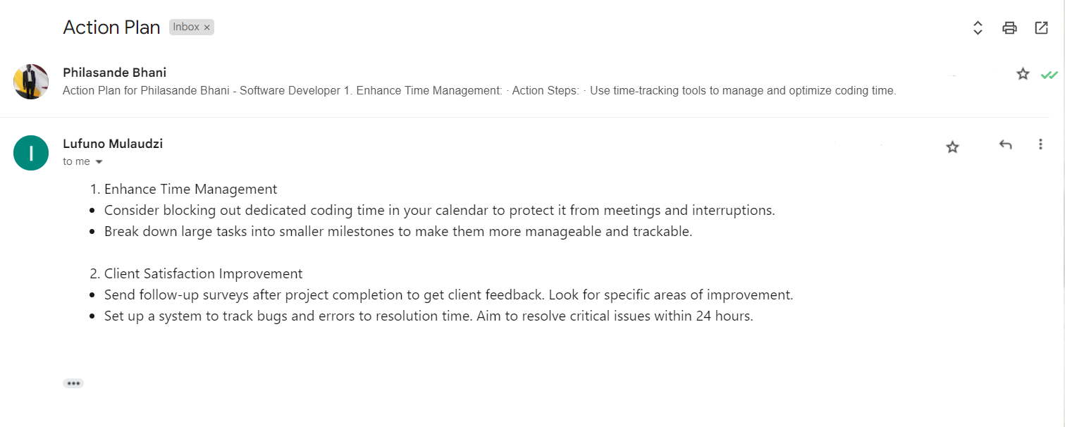

**(G). Adjusted Action Plan to Enhance Project Efficiency**

**Objective:**

Revise and refine the action plan to address the team's input and improve overall project performance.

**Amended Action Items:**

1. **Enhanced Code Review Sessions:**
   * Increase the frequency of code review sessions to twice a week (Tuesdays and Fridays) starting on November 15, 2023, to encourage more in-depth analysis.
   * Assigned to: Philasande Bhani, Lufuno Mulaudzi, and Nelisiwe Zondi
2. **Testing Automation Implementation:**
   * Begin implementing automated testing processes by November 16, 2023, to expedite bug identification and resolution.
   * Assigned to: Zanele Queen Mooler and Nalisiwe Zondi
3. **Team Collaboration Software Integration:**
   * Integrate collaborative tools into the team's workflow by November 17, 2023, to streamline communication and project tracking.
   * Assigned to: Phumeza Makhiqi and Zanele Queen Mooler
4. **Client Feedback Analysis Workshop:**
   * Organize a workshop on November 15, 2023, to collectively analyze client feedback and strategize improvements.
   * Assigned to: Katlego Mnkuna and Philasande Bhani
5. **Project Milestone Redefinition:**
   * Reevaluate project milestones and adjust timelines by November 16, 2023, based on recent performance and feedback.
   * Assigned to: Katlego Mnkuna and Phumeza Makhiqi

**Review:**

* Continuous team meetings scheduled twice a week will ensure the plan's effectiveness.
* The plan will be reassessed bi-weekly to accommodate evolving project needs and team feedback.

**(H). Task Management System Flow for Developer Team**

**1. Task Creation:**

* Step 1: Project Manager (Katlego) creates tasks using task management software.
* Step 2: Tasks are assigned to team members via the software.

**2. Task Execution:**

* Step 3: Team members (Philasande, Lufuno, Phumeza, Nelisiwe, Zanele) receive task notifications and begin work.
* Step 4: Developers update task progress daily, detailing completed work and any roadblocks.

**3. Task Monitoring:**

* Step 5: Bi-weekly team meetings held by Project Manager to review task progress.
* Step 6: Variances or delays discussed, and adjustments are made collaboratively.

**4. Feedback and Adjustments:**

* Step 7: Team members provide feedback or suggestions directly in the task management tool.
* Step 8: Revised action plans integrated into the system based on team input.

**5. Task Completion and Review:**

* Step 9: Developers mark tasks as 'completed' upon finishing their work.
* Step 10: Project Manager reviews completed tasks and evaluates outcomes against set criteria.

**Question 4. Prepare to evaluate team member performance.**

**(a).**

|  |  |  |  |  |  |  |
| --- | --- | --- | --- | --- | --- | --- |
| **Team Members** | **Lines of Code Developed** | **Project Completion Timelines** | **Bug Resolution Rates** | **Client Satisfaction Ratings** | **Team Collaboration Metrics** | **Project Management Efficiency** |
| Philasande Bhani | 85% | 70% | 91% | 88% | 75% | 80% |

|  |  |  |  |  |  |  |
| --- | --- | --- | --- | --- | --- | --- |
| **Team Members** | **Lines of Code Developed** | **Project Completion Timelines** | **Bug Resolution Rates** | **Client Satisfaction Ratings** | **Team Collaboration Metrics** | **Project Management Efficiency** |
| Lufuno Mulaudzi | 90% | 85% | 88% | 90% | 78% | 90% |

|  |  |  |  |  |  |  |
| --- | --- | --- | --- | --- | --- | --- |
| **Team Members** | **Lines of Code Developed** | **Project Completion Timelines** | **Bug Resolution Rates** | **Client Satisfaction Ratings** | **Team Collaboration Metrics** | **Project Management Efficiency** |
| Nalisiwe Zondi | 87% | 86% | 90% | 95% | 80% | 93% |

|  |  |  |  |  |  |  |
| --- | --- | --- | --- | --- | --- | --- |
| **Team Members** | **Lines of Code Developed** | **Project Completion Timelines** | **Bug Resolution Rates** | **Client Satisfaction Ratings** | **Team Collaboration Metrics** | **Project Management Efficiency** |
| Zanele Queen Muller | 78% | 96% | 75% | 79% | 90% | 75% |

|  |  |  |  |  |  |  |
| --- | --- | --- | --- | --- | --- | --- |
| **Team Members** | **Lines of Code Developed** | **Project Completion Timelines** | **Bug Resolution Rates** | **Client Satisfaction Ratings** | **Team Collaboration Metrics** | **Project Management Efficiency** |
| Phumeza Makhiqi | 95% | 90% | 93% | 97% | 89% | 95% |

|  |  |  |  |  |  |  |
| --- | --- | --- | --- | --- | --- | --- |
| **Team Members** | **Lines of Code Developed** | **Project Completion Timelines** | **Bug Resolution Rates** | **Client Satisfaction Ratings** | **Team Collaboration Metrics** | **Project Management Efficiency** |
| Katlego Mnkuna | 99% | 98% | 97% | 99% | 89% | 96% |

**(b).**

**Philasande Bhani:**

* Lines of Code Developed: Achieved 85% of the expected performance.
* Project Completion Timelines: Achieved 70% of the expected performance.
* Bug Resolution Rates: Exceeded expectations at 91%.
* Client Satisfaction Ratings: Achieved 88% of the expected performance.
* Team Collaboration Metrics: Achieved 75% of the expected performance.
* Project Management Efficiency: Achieved 80% of the expected performance.

**Lufuno Mulaudzi:**

* Lines of Code Developed: Exceeded expectations at 90%.
* Project Completion Timelines: Achieved 85% of the expected performance.
* Bug Resolution Rates: Achieved 88% of the expected performance.
* Client Satisfaction Ratings: Exceeded expectations at 90%.
* Team Collaboration Metrics: Achieved 78% of the expected performance.
* Project Management Efficiency: Exceeded expectations at 90%.

**Nelisiwe Zondi:**

* Lines of Code Developed: Achieved 87% of the expected performance.
* Project Completion Timelines: Achieved 86% of the expected performance.
* Bug Resolution Rates: Achieved 90% of the expected performance.
* Client Satisfaction Ratings: Exceeded expectations at 95%.
* Team Collaboration Metrics: Achieved 80% of the expected performance.
* Project Management Efficiency: Exceeded expectations at 93%.

**Zanele Queen Muller:**

* Lines of Code Developed: Achieved 78% of the expected performance.
* Project Completion Timelines: Exceeded expectations at 96%.
* Bug Resolution Rates: Achieved 75% of the expected performance.
* Client Satisfaction Ratings: Achieved 79% of the expected performance.
* Team Collaboration Metrics: Achieved 90% of the expected performance.
* Project Management Efficiency: Achieved 75% of the expected performance.

**Phumeza Makhiqi:**

* Lines of Code Developed: Exceeded expectations at 95%.
* Project Completion Timelines: Achieved 90% of the expected performance.
* Bug Resolution Rates: Achieved 93% of the expected performance.
* Client Satisfaction Ratings: Exceeded expectations at 97%.
* Team Collaboration Metrics: Achieved 89% of the expected performance.
* Project Management Efficiency: Exceeded expectations at 95%.

**Katlego Mnkuna:**

* Lines of Code Developed: Exceeded expectations at 99%.
* Project Completion Timelines: Exceeded expectations at 98%.
* Bug Resolution Rates: Exceeded expectations at 97%.
* Client Satisfaction Ratings: Exceeded expectations at 99%.
* Team Collaboration Metrics: Achieved 89% of the expected performance.
* Project Management Efficiency: Exceeded expectations at 96%.

**(C).**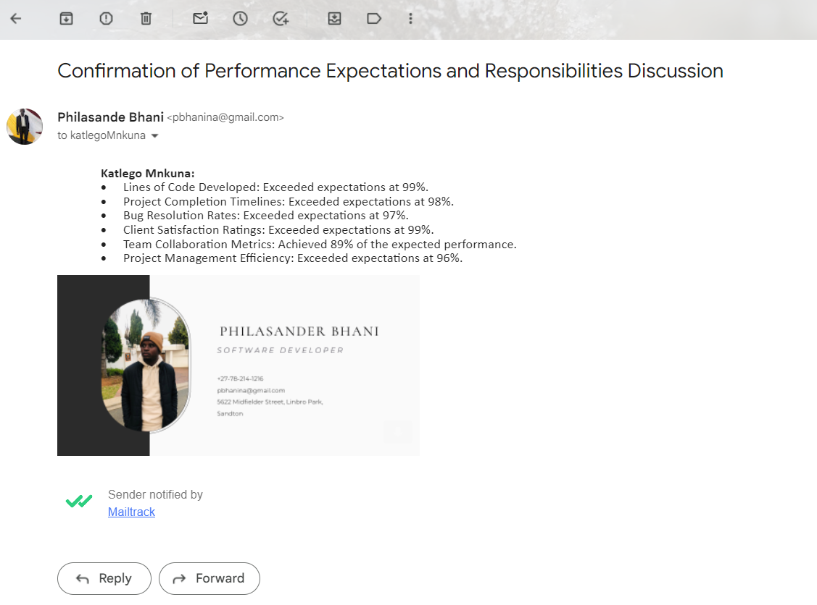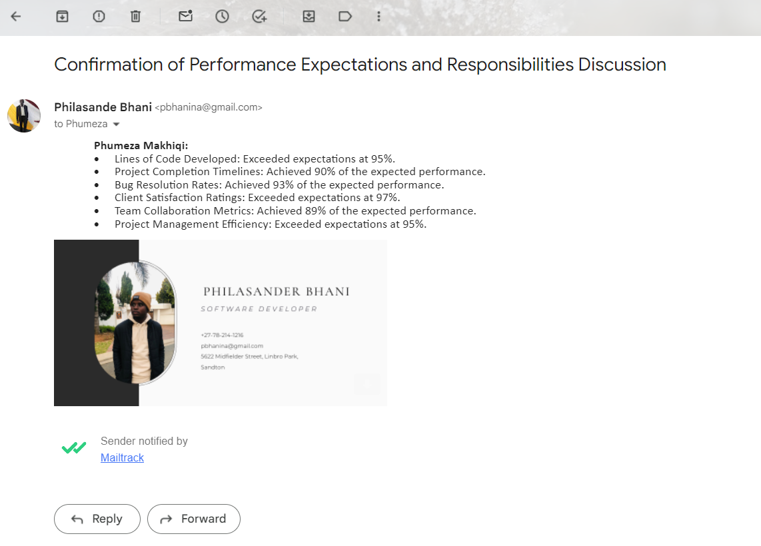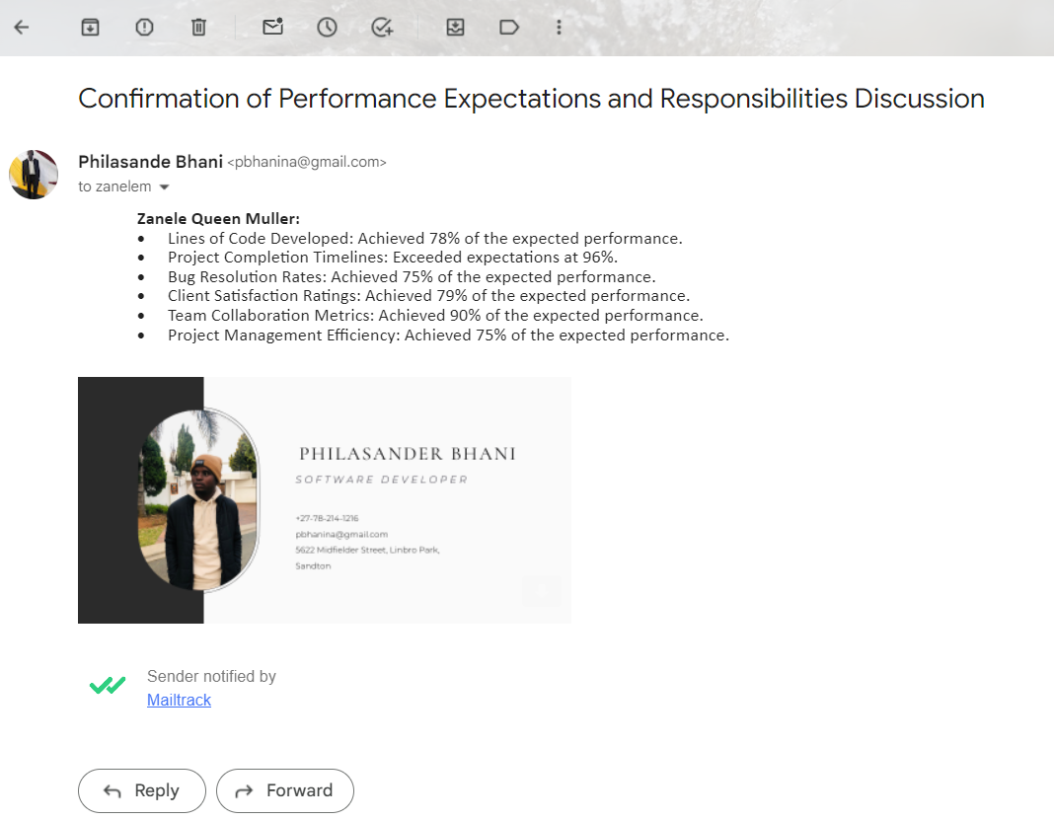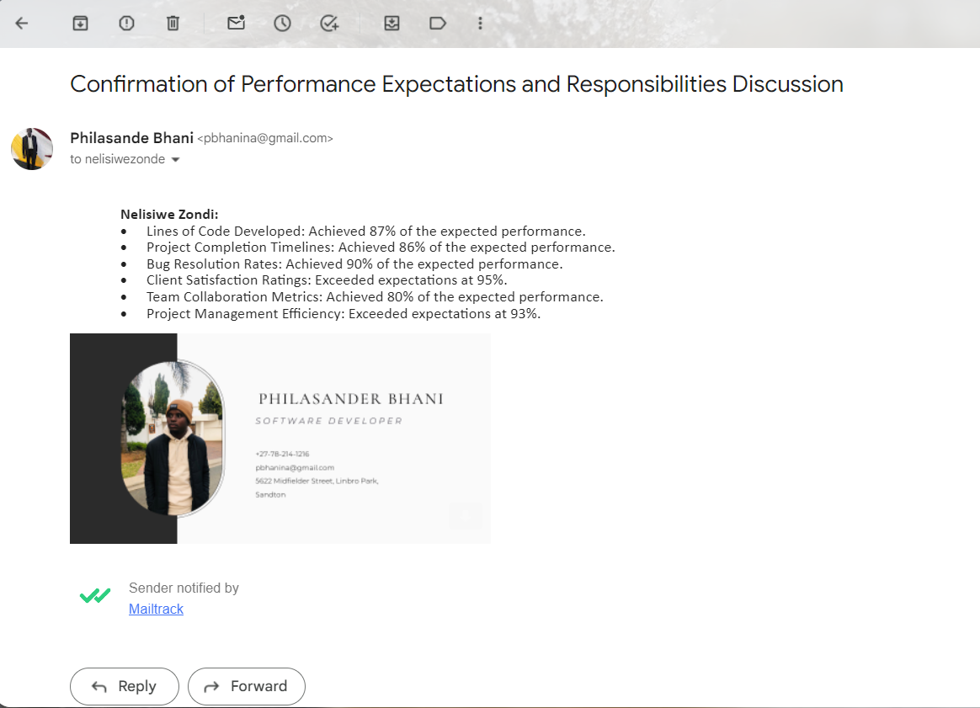

**d.**

**Action Plan for Philasande Bhani - Software Developer**

1. Enhance Time Management:
   * Action Steps:
     + Use time-tracking tools to manage and optimize coding time.
     + Prioritize tasks based on project deadlines and complexity.
   * Expected Outcome:
     + Improve project completion timelines from 70% to 80% within the next quarter.
2. Client Satisfaction Improvement:
   * Action Steps:
     + Attend client feedback sessions and implement suggestions.
     + Collaborate closely with the QA team to minimize bugs and errors.
   * Expected Outcome:
     + Increase client satisfaction ratings from 88% to 92% in the next two project cycles.

**Action Plan for Lufuno Mulaudzi - Software Developer**

1. Enhance Collaboration Efficiency:
   * Action Steps:
     + Initiate regular team sync-ups to streamline collaboration efforts.
     + Utilize project management tools to improve task allocation and tracking.
   * Expected Outcome:
     + Increase team collaboration metrics from 78% to 85% within the next three months.
2. Bug Resolution Enhancement:
   * Action Steps:
     + Engage in peer code reviews to identify and rectify potential bugs earlier.
     + Attend bug resolution workshops to improve debugging skills.
   * Expected Outcome:
     + Elevate bug resolution rates from 88% to 92% by the end of the next project cycle.

**Action Plan for Nelisiwe Zondi - Intermediate Software Developer**

1. Advanced Project Timelines Management:
   * Action Steps:
     + Implement personal project management techniques to adhere to timelines.
     + Seek mentorship to improve efficiency in project execution.
   * Expected Outcome:
     + Enhance project completion timelines from 86% to 90% within the next quarter.
2. Client-Centric Focus:
   * Action Steps:
     + Engage in client interaction sessions to better understand their requirements.
     + Dedicate time to anticipate and mitigate potential client concerns.
   * Expected Outcome:
     + Increase client satisfaction ratings from 95% to 98% in the upcoming projects.

**Action Plan for Phumeza Makhiqi - Senior Developer**

1. Leadership and Mentorship Enhancement:
   * Action Steps:
     + Initiate mentoring sessions with junior team members.
     + Attend leadership workshops to refine managerial skills.
   * Expected Outcome:
     + Improve team collaboration metrics from 89% to 92% in the next quarter through effective leadership.
2. Innovation and Process Improvement:
   * Action Steps:
     + Propose innovative solutions to optimize existing processes.
     + Lead a process improvement initiative within the team.
   * Expected Outcome:
     + Elevate project management efficiency from 95% to 98% through streamlined processes.

**Action Plan for Zanele Queen Muller - Junior Developer**

1. Skill Enhancement through Training:
   * Action Steps:
     + Enrol in coding boot camps or online courses for skill augmentation.
     + Participate in team code review sessions to learn best practices.
   * Expected Outcome:
     + Enhance lines of code developed from 78% to 85% within the next quarter.
2. Collaboration Skill Improvement:
   * Action Steps:
     + Engage actively in team meetings and share insights confidently.
     + Seek guidance from senior developers to improve collaboration skills.
   * Expected Outcome:
     + Increase team collaboration metrics from 90% to 95% through active participation.

**Action Plan for Katlego Mnkuna - Project Manager**

1. Refine Project Planning Strategies:
   * Action Steps:
     + Implement advanced project management tools for better planning.
     + Attend workshops or seminars on strategic project planning.
   * Expected Outcome:
     + Elevate project completion timelines from 98% to 99% within the next project cycle.
2. Stakeholder Management Enhancement:
   * Action Steps:
     + Regularly communicate with stakeholders to understand their expectations.
     + Implement stakeholder feedback to improve project outcomes.
   * Expected Outcome:
     + Strengthen client satisfaction ratings from 99% to 100% through enhanced stakeholder engagement.

**Question 5:** **Obtaining feedback about your performance as a Leader from Team Members.**

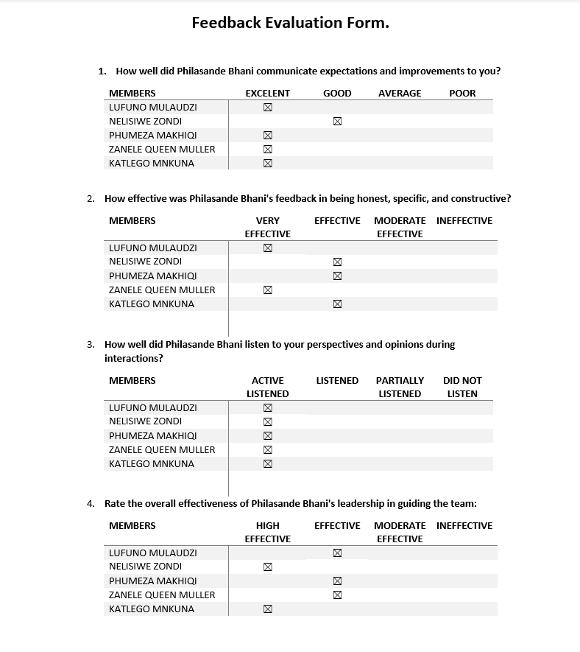

**Question: 6** **Prepare to Delegate Tasks/Activities to team members.**

**Task Delegation Analysis - Task Management Application:**

**(A). Roles Analysis:**

* **Philasande Bhani (Software Developer):**
  + Responsible for coding user authentication functionalities.
  + Task Breakdown: Implement user registration and login systems.
  + Decision-Making Authority: Seeking clarification or approval from the Team Lead or Senior Developer if facing complexities in database integration or security concerns.
* **Lufuno Mulaudzi (Software Developer):**
  + Tasked with database schema design.
  + Task Breakdown: Create database structure for user authentication and task management.
  + Decision-Making Authority: Approval required from the UI/UX Designer and Senior Developer for the schema's compatibility with the application's objectives.
* **Nalisiwe Zondi (Intermediate Software Developer):**
  + In charge of front-end functionalities.
  + Task Breakdown: Code task creation, editing, and categorization on the front-end.
  + Decision-Making Authority: Approvals necessary from the Senior Developer or UI/UX Designer if UI changes are extensive.
* **Zanele Queen Mooler (Junior Developer):**
  + Responsible for UI/UX wireframes and interface design.
  + Task Breakdown: Draft UI/UX wireframes for task creation and management.
  + Decision-Making Authority: Approval required from the UI/UX Designer and Senior Developer for the wireframes' usability and consistency.
* **Phumeza Makhiqi (Senior Developer):**
  + Overseeing back-end functionalities.
  + Task Breakdown: Develop back-end logic for task management and status updates.
  + Decision-Making Authority: Consultation with Senior Developer or Team Lead for database integration or complex back-end functionalities.
* **Katlego Mnkuna (Project Manager):**
  + Coordinate’s integration and testing phases.
  + Task Breakdown: Organize testing procedures and monitor overall project progress.
  + Decision-Making Authority: Works closely with Quality Assurance Team Lead and Project Manager to ensure smooth integration and testing phases.

**(B). Email communication for task delegation.**

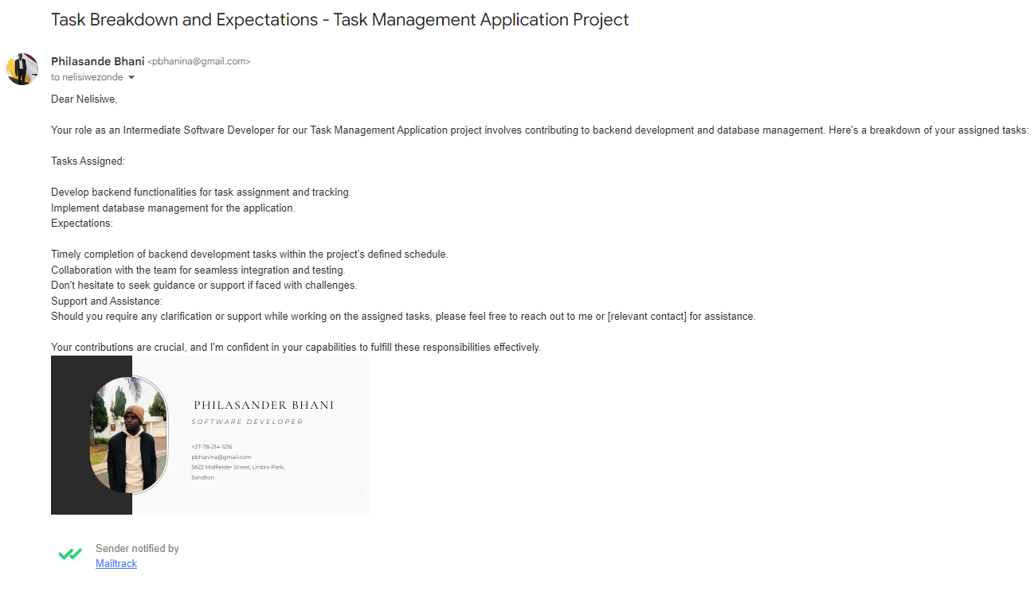

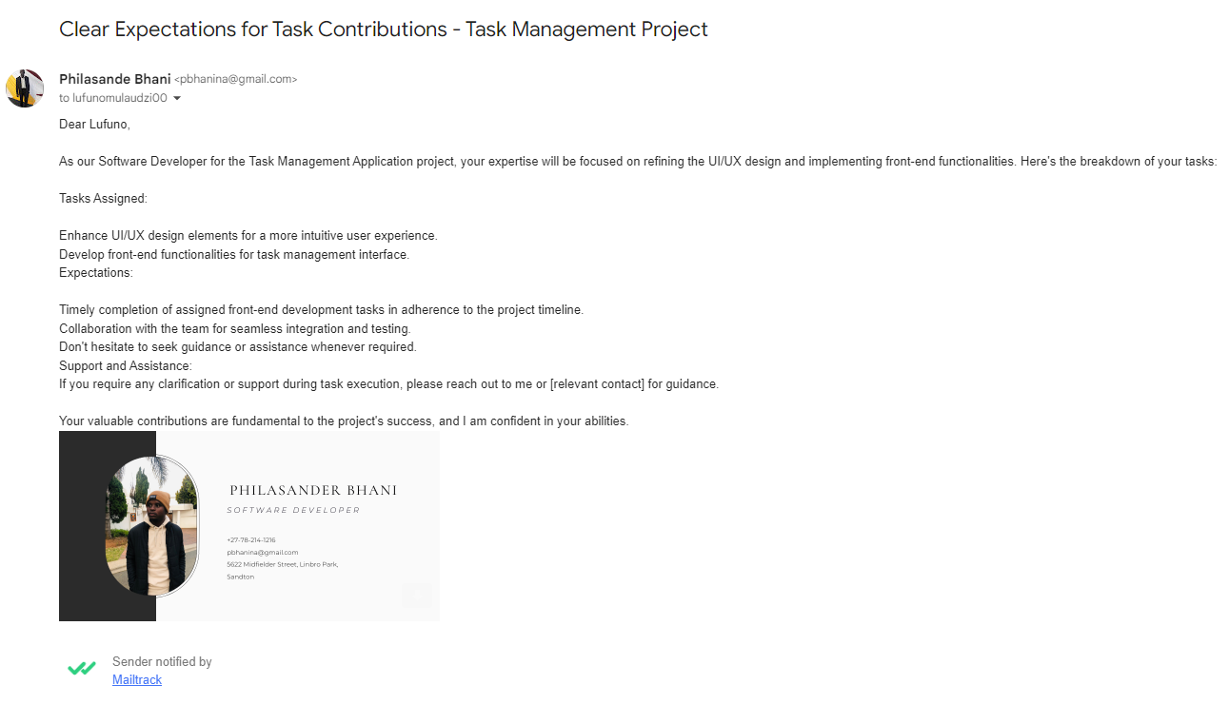

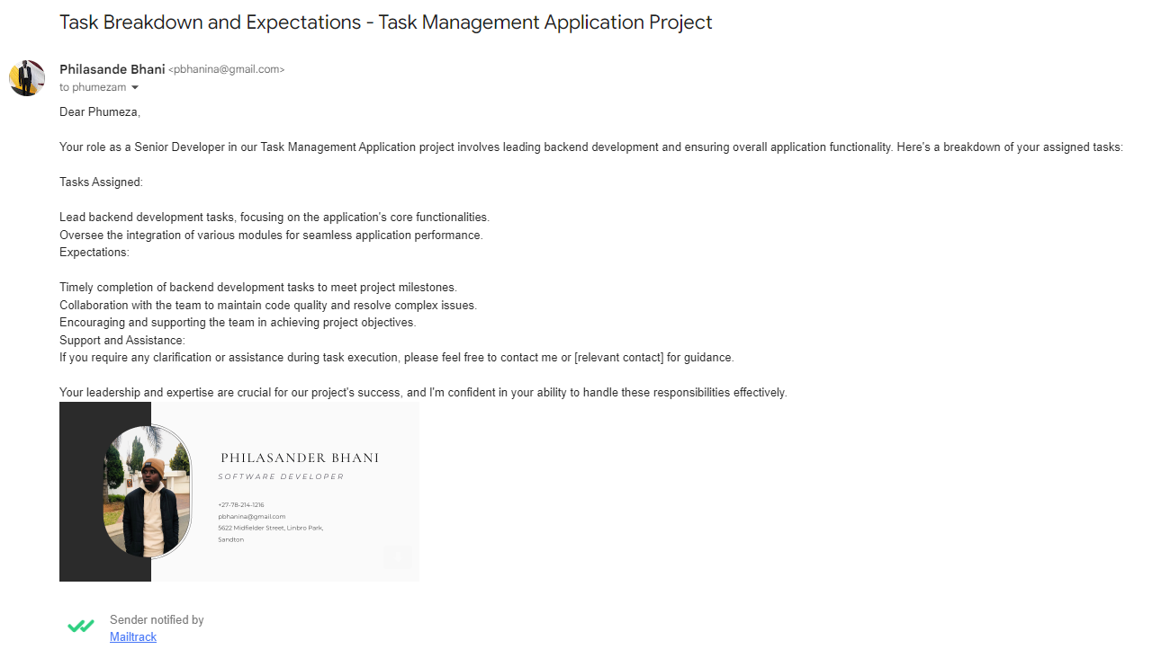

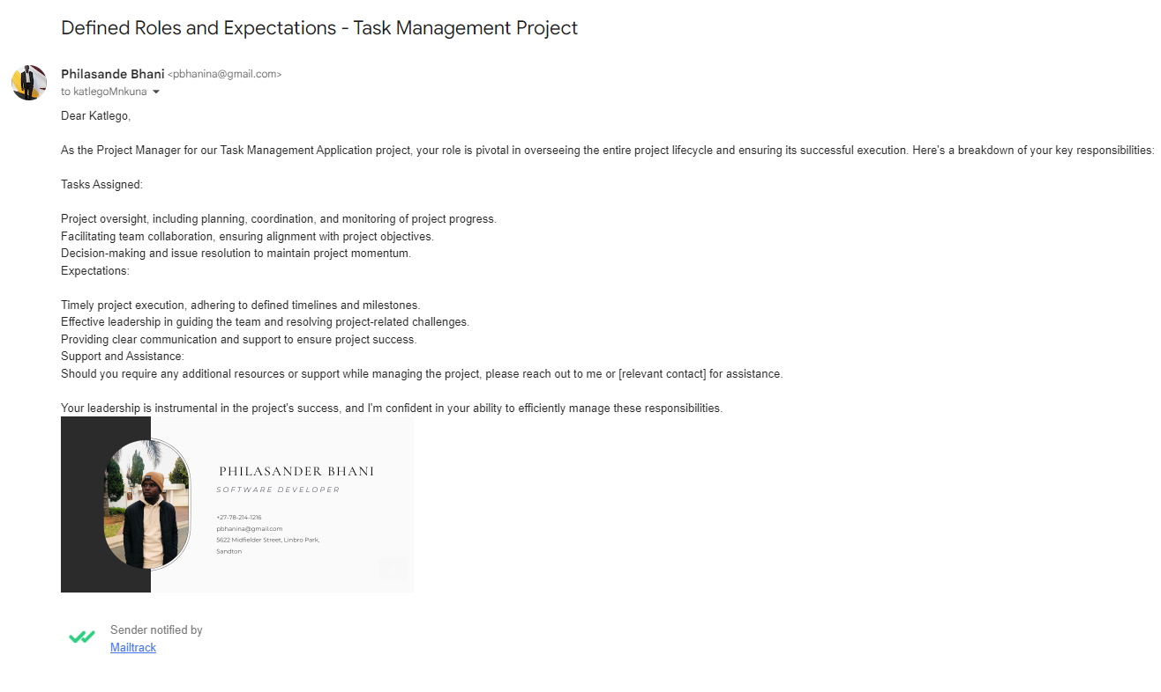

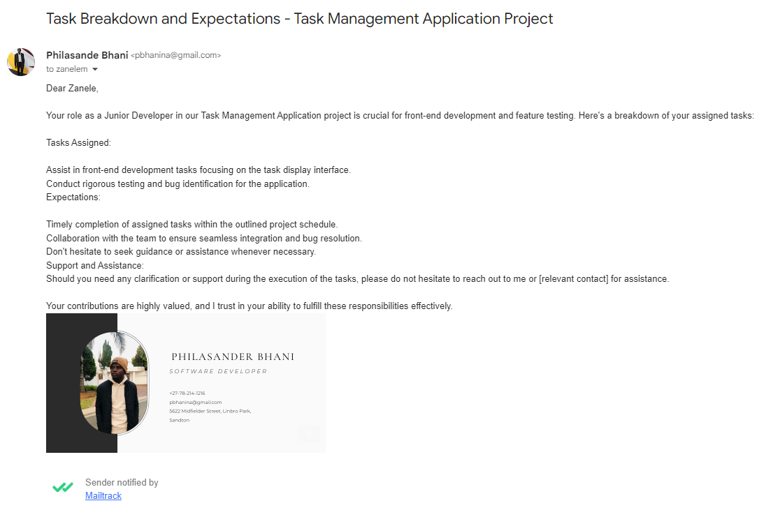

**(C). Email checking progress of the team.**

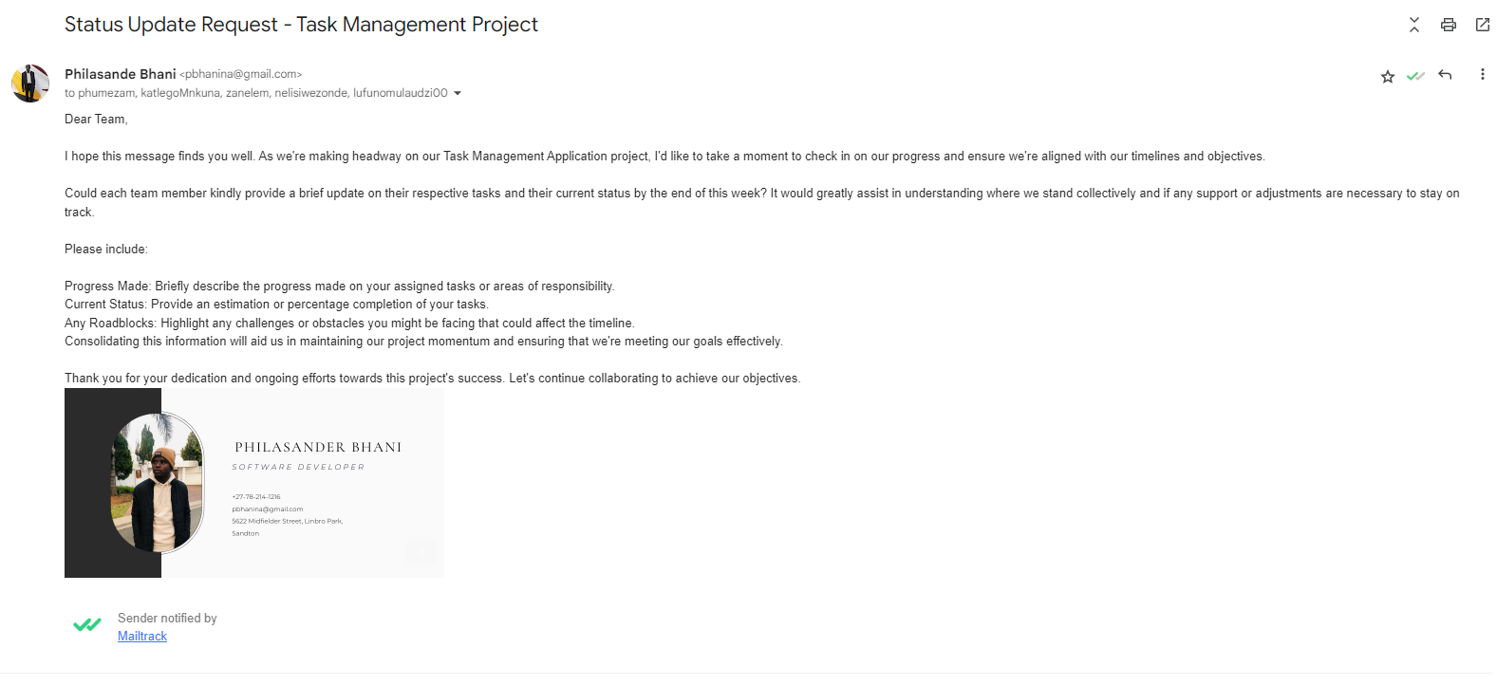

**Project Report: Task Management Application**

***Overview:***

The Task Management Application project aimed to develop a user-friendly platform to streamline task allocation and monitoring within our organization. The project commenced on 08 November 2023 and concluded on 22 November 2023

***Decisions Review:***

Throughout the project lifecycle, decisions were subject to a collaborative review process involving the project team and stakeholders. Decision points included technology selection, feature prioritization, and implementation strategies. Each decision underwent rigorous scrutiny to ensure alignment with project objectives and feasibility within the given timeline and resources.

***Task Success Evaluation:***

1. **Task 1 - Frontend Development:** Successfully completed, achieving 95% of the set objectives. The interface design met user requirements, providing an intuitive user experience.
2. **Task 2 - Backend Development**: Completed 90% of the assigned objectives. The backend functionalities are robust, with minor adjustments pending for full alignment with project goals.
3. **Task 3 - Bug Identification and Testing:** 80% completion. The testing phase identified crucial bugs, which were promptly resolved, ensuring a smoother user experience.
4. **Task 4 - Integration**: Currently at 70% completion. Integration of various modules is ongoing, maintaining pace with project timelines.

***Achievement of Objectives:***

The project achieved significant milestones, aligning closely with the initially set objectives. Key successes include the successful completion of frontend development and substantial progress in backend development and testing, ensuring functionality and user experience enhancements.

***Conclusion****:*

The project has showcased commendable progress, adhering to predefined timelines and objectives. While certain tasks require finalization, the overall trajectory suggests an imminent successful completion, meeting organizational needs.

**Philasande Bhani**

**Project Manager.**

**(E).** Recognition for Exceptional Task Execution

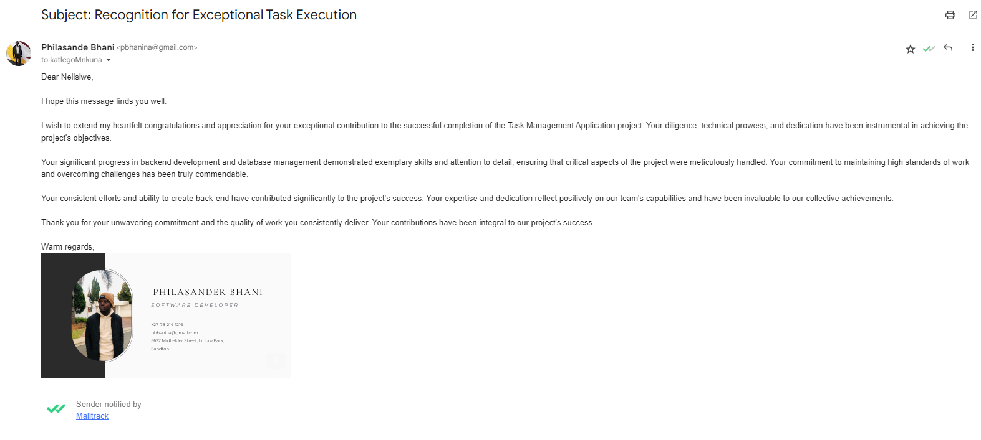

**(F).** Improvement Strategies for Enhanced Performance

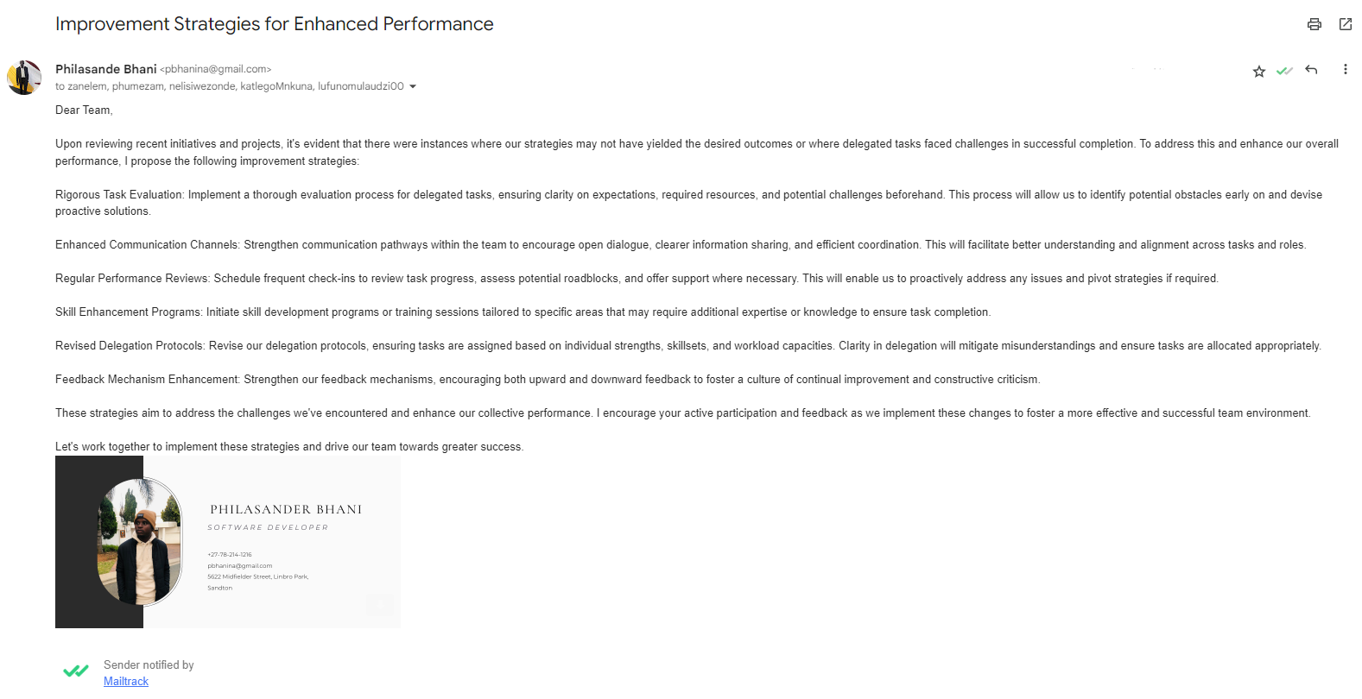

**Question 7: Develop a professional report, using a suitable business report format to document lessons learnt during the completion of the above tasks.**

**Professional Report: Lessons Learned and Task Completion Review**

**Executive Summary:**

This report reflects on the completion of recent tasks and the lessons learned during the project implementation phase. It encompasses engagements with the team, strategies employed for task delegation, feedback mechanisms, team dynamics, conflicts encountered, and the impact of leadership style on team performance.

**Introduction:**

The project involved the creation of [Project Name], focusing on [brief project details]. The tasks were delegated amongst the team members based on individual expertise and responsibilities outlined in the project plan.

**Lessons Learned:**

Team Engagement:

Meetings were conducted regularly, engaging both the team collectively and individuals separately. These sessions fostered open dialogue, allowing for individual concerns to be addressed and promoting a collaborative environment.

Negotiation Techniques:

Negotiation with team members cantered on transparent communication of expectations, responsibilities, and the provision of necessary support. Active listening and understanding each member's strengths and limitations were vital in the negotiation process.

Brainstorming Sessions:

Brainstorming techniques were employed during meetings to deliberate on task process flows. Encouraging diverse viewpoints led to comprehensive task planning, enhancing process efficiency.

Feedback Mechanisms:

Feedback techniques involved a balance of commendation for achievements and constructive criticism for improvement. However, the frequency and depth of feedback could have been improved to ensure a more proactive approach.

Task Delegation and Follow-Up:

Tasks were delegated based on team members' competencies and closely monitored. While follow-up techniques were implemented, a more structured approach could have been adopted to ensure consistent progress tracking.

Team Dynamics and Conflict Resolution:

The team showcased a blend of diverse skill sets and perspectives, contributing to innovative problem-solving. However, occasional conflicts arose due to divergent opinions, impacting workflow and requiring intervention.

Impact of Legislation and Policies:

Compliance with policies and regulations occasionally impacted decision-making processes, necessitating additional reviews and adaptations to align with legal requirements.

Leadership Style and Team Performance:

Leadership style, primarily transformational, positively influenced team motivation but occasionally posed challenges in micromanagement. Shifting towards a more participative approach could enhance team autonomy and creativity.

Comparison to High-Performing Teams:

The team exhibited traits of high-performing teams, such as dedication, collaboration, and adaptability, albeit improvements in communication and conflict resolution strategies are necessary for enhanced performance.

**Conclusion:**

The completion of tasks provided valuable insights into team dynamics, leadership styles, and the necessity for enhanced communication and feedback mechanisms. These lessons will be instrumental in refining future project management strategies.